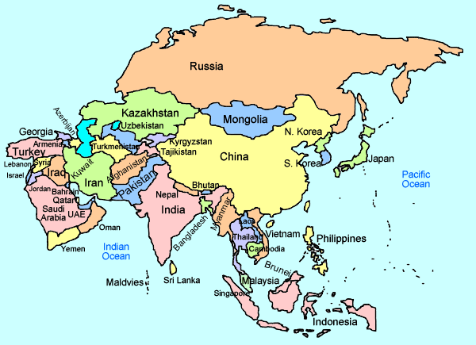
Hello my name is Bithi, I am 12 years old and I live in Dhaka in Bangladesh.
Bangladesh
For work I sew the pockets onto Blue Jeans, I have to sew on 60 pockets an hour.
There are 20 of workers squashed into a small second-story room, with very harsh lighting.
I have to work at such a young age because my dad is very poorly, so he cannot work to earn our family money.
On my first day I felt very bad, I was too small and I was surrounded by so many older people, I cried a lot.
I help to make around 480 pairs of jeans for about $1 in wages.
I wanted to become a doctor, but unfortunately, I had to leave school to work. And I no longer will be able to follow that dream.

https://www.worldvision.org/child-protection-news-stories/child-labor-garment-factory-bangladesh

