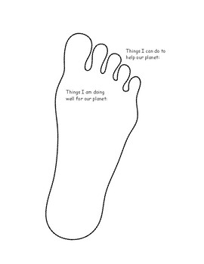

**Ideas to help you**

**Think about: Travel, holidays , food, buying clothes , waste, lights and energy use , water use, washing clothes .**

**How else can I help the planet?**

**What do I need to do better to reduce my carbon footprint?**

**The Ten Tonne Challenge – My carbon footprint**