Aim of the Climate Change group:
Following on from the connections made and conversations that took place at our Interfaith Week 2017 Climate Change event, we have set up a facebook group to keep the discussions and peer sharing going.

Once you have joined the group you’ll be able to start and add to discussions in the group, share information about climate change events or activity, put out questions to the group and follow what others are up to.

How to join:
- Go to www.facebook.com and log in as yourself.
- Search ‘Faith & Climate Network Merseyside’ in the facebook search box. Look for the logo above to find the correct group. (or go to https://www.facebook.com/groups/faithandclimatenetwork/)
- Click on the blue ‘+ Join group’ button, shown in the image below
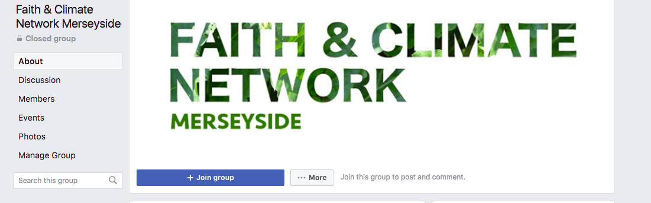
- Wait for your request to be ‘accepted’. This will be done by a member of the Faiths4Change team as quickly as possible after you request it. You will get a ‘notification’ the next time you log in to facebook to let you know it’s happened.
- You’ll get notifications from facebook when things are posted in the group. You can change your personal settings to allow for more/less notifications from a group.

How to post in the group:
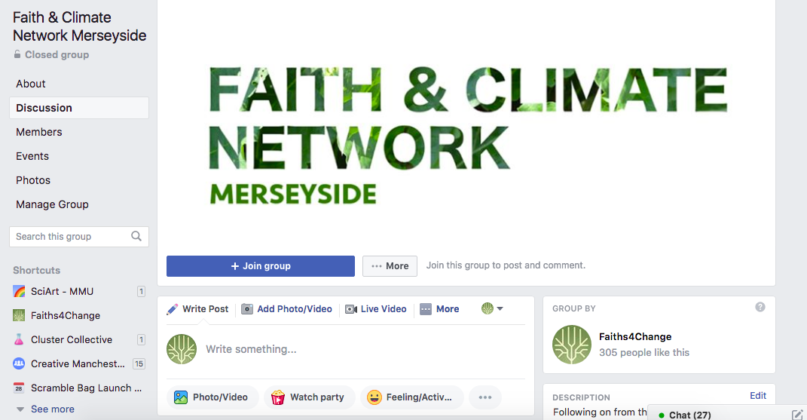

- Click on the ‘Discussion’ tab on the left hand side of the Faith & Climate Network group page.
- Use the ‘Write something.’ box (shown in the image above) to start a new discussion topic / share photographs, videos or website links / give information about upcoming events etc.
- You will be able to add your comments to other people’s posts too, scroll down the page to find what other people have already posted.

