Resources Group 4 Worksheet 1 Independent Cut and Stick
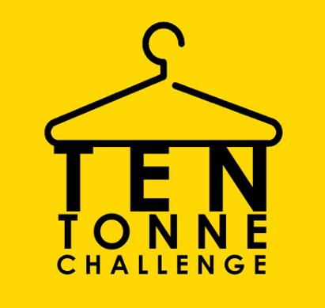 Name: ______________

Positively Effects the Environment | Negatively Effects the Environment

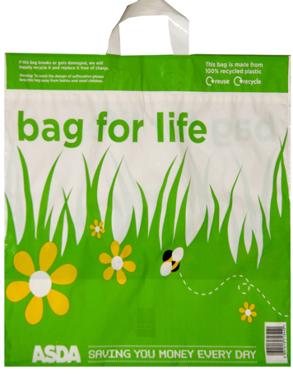
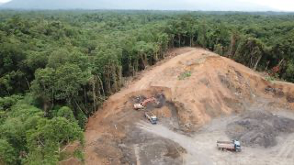

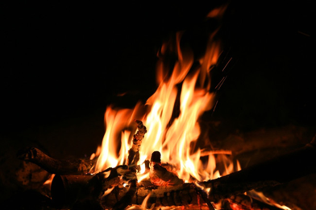
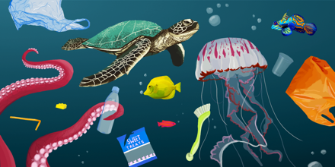

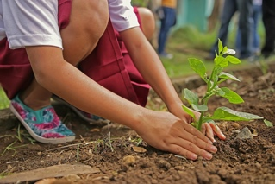

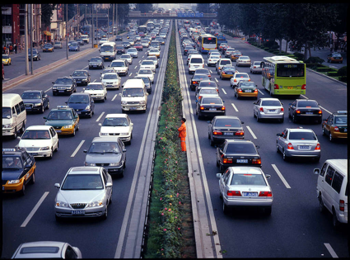
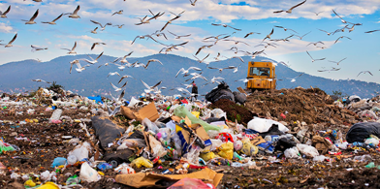

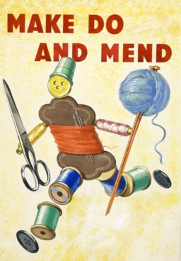

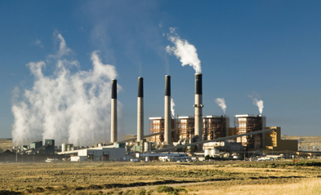

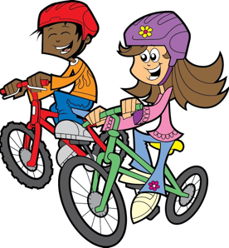
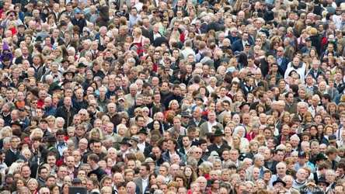
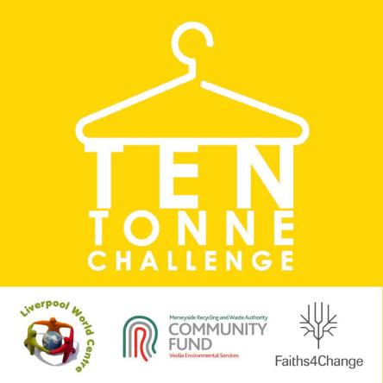
Resources Group 4 Worksheet 1

Resources Group 4 Worksheet 3
Video used to introduce Clothes Journey:
The life cycle of a t-shirt - Angel Chang
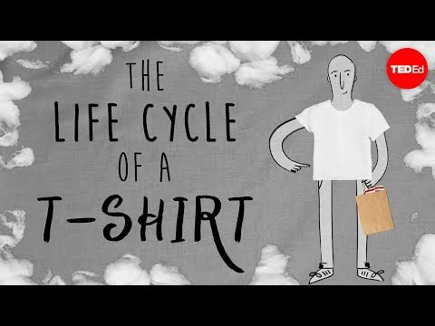

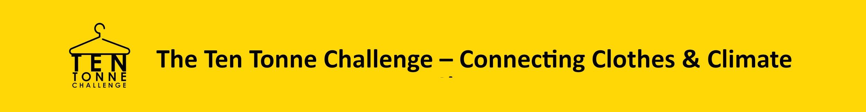
Resources Group 4 Worksheet 4
Case Study 1:
https://waronwant.org/news-analysis/sweatshop-worker-tells-her-story
Arifa from Bangladesh
Arifa started working in Bangladesh's garment factories when she was 10 years old.
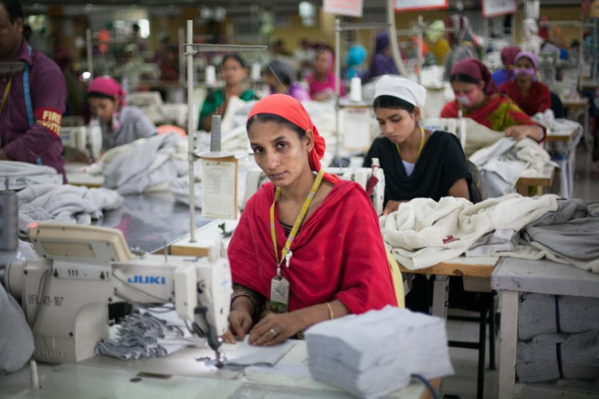

Case Study 2:

BIO-BEAN:
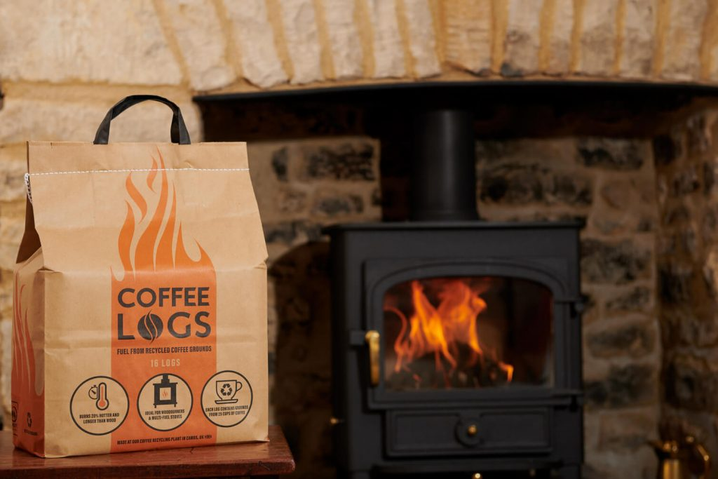
Bio-bean recycles waste coffee grounds to make Coffee Logs. Each carbon neutral log is made from the grounds of 25 cups of coffee and burns 20% hotter and longer than kiln-dried wood. Repurposing coffee waste generates 80% less emissions than if the grounds go to landfill.
Bio-bean’s ethos is that there is no such thing as waste – only resources in the wrong space.

Resources Group 4 Worksheet 2 Group Worksheets for Discussing Effects of Clothes on Planet:

