**How to make your very own dream catcher**

**Ages: 4-11**

**Type of activity:**

***What you will need:***

* Paper-plate (if not you can use card/cardboard)
* Scissors
* Glue
* Scrap fabric/Old clothes
* Pen/ Pencil

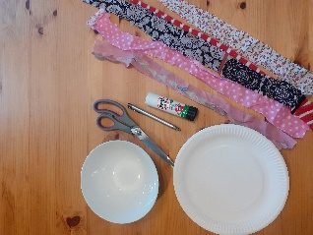

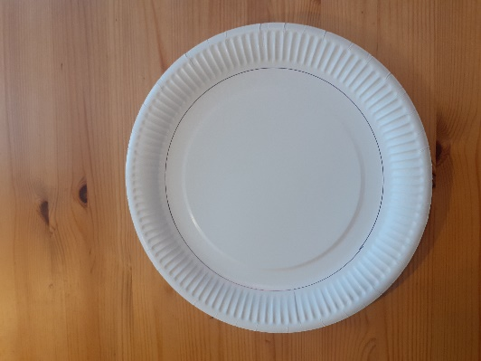

**Step One:** Find a circle shaped object to draw around, onto the paper-plate, leaving around a 3cm rim around the edge.

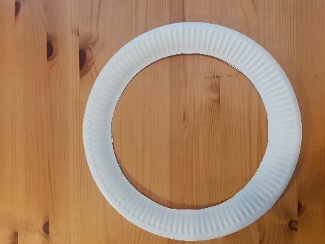

**Step Two:** Fold the paper-plate slightly to be able to snip to make a little hole.

**Step Three:** Cut into the plate using the hole, to follow the circle line that you drew. Leaving you with an outer circle

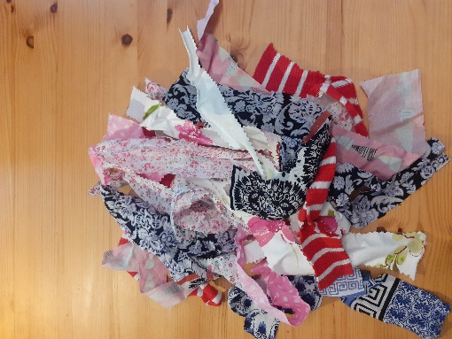

**Step Four:** Using old clothes/scrap fabric, cut into varying width and length strips.

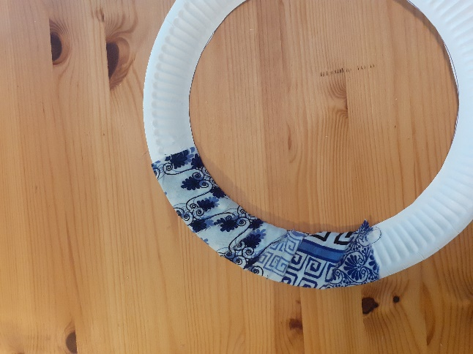

**Step Five:** Pick a strip of fabric, then stick it onto the outer paper circle. Wrap the fabric around to create a pattern. Then glue to secure down.

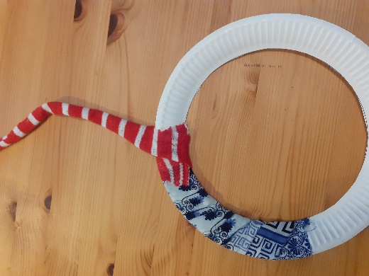

**Step Six:** Repeat step 5, but using a different fabric strip. You could choose a different, size/colour/pattern fabric strip.

**Step Seven:** Repeat this until all the circle is covered.

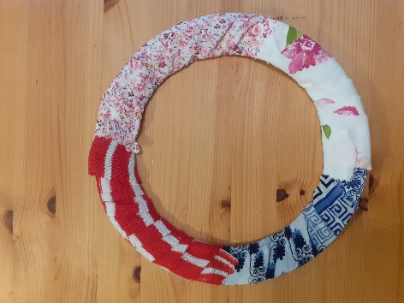

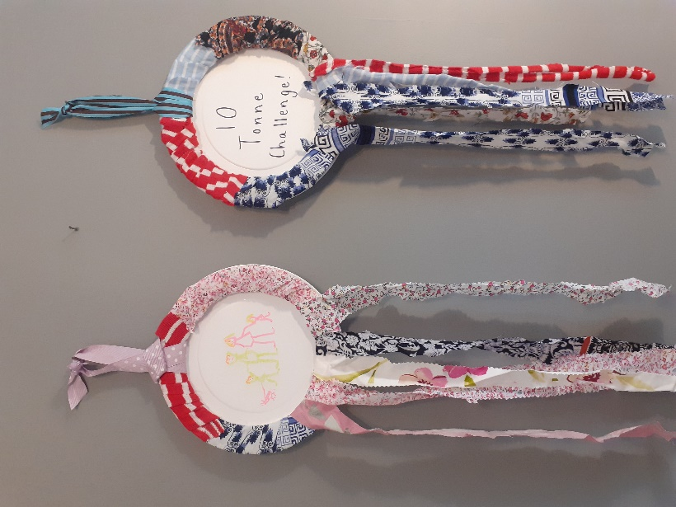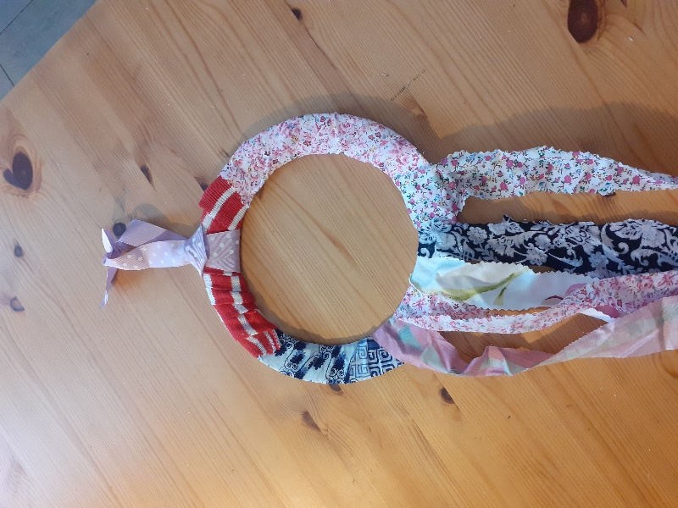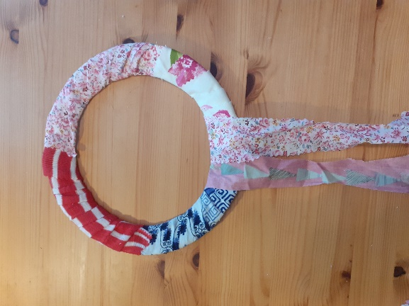

**Extra Step:** To make your dream catcher extra special you could draw a design on another paper plate and stick it to the back of your dream catcher.

**Step Nine:** Choose a fabric strip/ribbon to tie at the top for hanging.

**Step Eight:** Choose another fabric strip and stick to the bottom of the circle. Then repeat with different fabric strips, to create an interesting design.