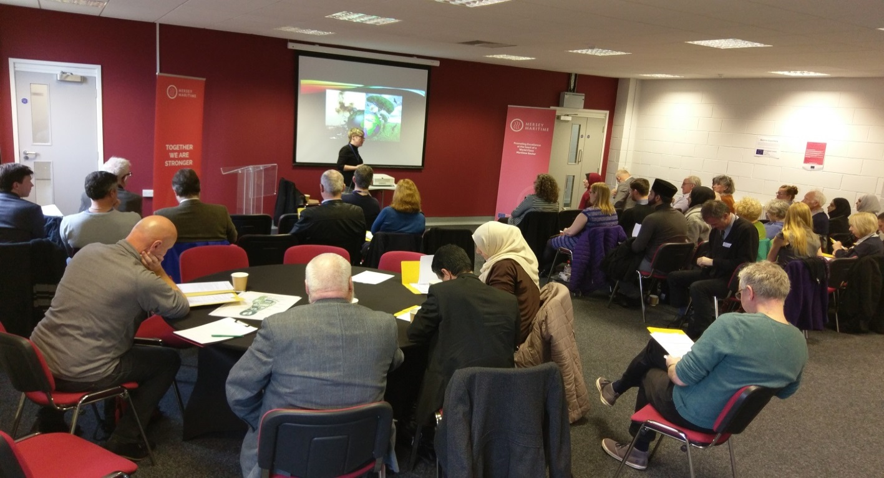
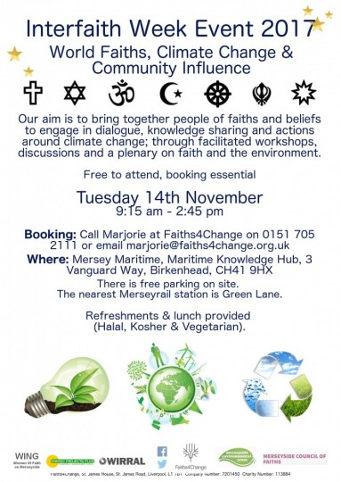

Event Report

Contents

Background and partners

Press release: introduction to the event
Organisations attending the event
Workshop discussions
Actions we are taking
Actions we’d like to or intend to take
Reflections and conclusions
Appendix: Faith based initiatives

Wirral Metropolitan Borough Council (WMBC) has an active climate change strategy – Cool 2014 – 19. The strategy, specifically goals focused on engaging with faith communities, provided the initial impetus for the Event. Establishing the event as an Interfaith Week one, made complete sense – it provided the first step opportunity to bring faith and climate change together and generated considerable support, interest and engagement as a result.

Background & partners

https://www.interfaithweek.org/

https://www.wirral.gov.uk/sites/default/files/all/About%20the%20council/climate%20change/Wirral%20Climate%20Change%20Strategy%202014-2019.pdf

The strategy covers the period 2014 to 2019. It has two main goals:
- to substantially cut climate pollution associated with Wirral
- to adapt Wirral to unavoidable climate change

These goals are supported by aims to:
- Reduce demand for energy and make Wirral more energy efficient
- Generate and source more of our local energy needs from 'renewable' sources
- Use more sustainable modes of transport, more fuel-efficient vehicles and less polluting means of getting around; and
- Reduce the indirect negative impacts that our decisions have for climate pollution in Wirral and elsewhere
- Identify the risks and vulnerabilities from expected changes and bring forward plans and actions to limit negative impacts and improve resilience
- Build capacity for action by strengthening local networks and partnerships and by developing wider awareness and education initiatives

The Cool strategy is a live document which provides measurable activities, some of which are delivered through organisations who are members of the Cool Wirral Partnership (formerly the Wirral Climate Change Action Group).

Energy Projects Plus, Faiths4Change and Planet Heswall are all active members of the Cool Wirral Partnership and worked together with Emansys to deliver the World Faiths, Climate Change and Community Influence event. We wanted the event to be the first step to closer working engaging statutory, third sector, private sector and faith community partners on climate change.

Faiths4Change was the lead partner with Wirral MBC on the event. We worked closely to define the initial focus; including a city region wide and multi-faith approach to enable dialogue and sharing of values, beliefs and actions on climate change between people of different faiths with the Liverpool City Region. Faiths4Change led the development and delivery of the event, including engaging support and partnership working, research and publicity, structure, delegate bookings and information and report writing. F4C will continue to lead progress beyond the event, which is considered to be a first step towards closer working with faith communities on climate change.

Faiths4Change is a registered charity working across the North West of England. F4C works in partnership with people of different world faiths and none to develop trusted relationships and skills that ultimately transform lives, communities and environments. F4C works in partnership with others to create practical projects, events and services such as food growing and making and creative arts that bring people together to develop healthier, more just neighbourhoods in which people and the environment flourish. Faiths4Change are associate members of Merseyside Council of Faiths, core members of Wing – Merseyside’s women’s faith network and are on the board of Liverpool Food People (Liverpool’s sustainable food city network).
http://www.faiths4change.org.uk/

Planet Heswall, developed and delivered the ‘Community Influence’ workshop strand, helped to develop the structure of the event, contributed lots of relevant information on faith and climate change and publicised the event locally. PH is a new group for Heswall residents interested in exploring how we can live a more sustainable lifestyle. Planet Heswall hosts talks, activities, projects and is keen to provide a space to share ideas on how to help reduce Heswall’s environmental footprint.
Email planet.heswall@gmail.com

Energy Projects Plus developed and delivered the ‘Energy’ workshop strand, helped to develop the structure of the event, contributed lots of useful information on energy to share with event participants and publicised the event locally. http://www.epplus.org.uk/

Energy Projects Plus is an independent not-for-profit organisation and a registered environmental charity, formed in 1995. Energy Projects Plus mission is to continually seek opportunities to develop partnerships to improve energy efficiency, alleviate fuel poverty and reduce the impact on the environment through energy and sustainability projects. They have a team of over 20 staff delivering front-line projects that include;
- Advice giving.
- Raising awareness.
- Training and educational work programmes with local communities.
- Promotion and management of grants resulting in the installation of energy efficiency and renewables measures.
- Develop policies and strategies related to energy use and fuel poverty.
- Undertake studies addressing issues that affect take-up of action by energy users.
Emansys developed and delivered the ‘Waste, water and Carbon Footprint’ workshop strand and helped to develop the structure of the event. With Faiths4Change they developed initial ideas for an event prior to engagement with WMBC and other partners.

Emansys is a small dynamic consultancy established in January 2008 with over 30 years of experience in the chemical manufacturing and process industries as well as regeneration and environmental consultancy. Throughout their journey, they have maintained their commitment to helping small privately owned businesses as well as having the capability and capacity to work with larger businesses, the Public, Not for Profit and Education sectors. http://www.emansysuk.com/
The event could not have gone ahead without the generous support of Merseyside Environmental Trust whose grant paid for the venue and Wing whose grant paid for refreshments.

Thank you to all partners, supporters and all who participated in the event - it was memorable.

Organisations attending the event

Organisation
Heswall Gospel Hall, Wirral
Planet Heswall, Wirral
Al Ghazali Centre, Liverpool
Liverpool Ganesh Temple, Kirkby, Knowsley
St Bridget's Church of England Church, Caldy, Wirral
Merseyside Council of Faiths – Merseyside wide network
Wing – Merseyside Women’s Faith Group – Merseyside wide network
Merseyside Police
Sustainable living Projects: Wirral Environmental Network, Wallasey, Wirral
Heswall Quakers, Heswall, Wirral
Environment Agency – North West
Kingdom Life Church
Local Economic Partnership – Liverpool City Region
Cool Wirral Partnership, Wirral Metropolitan Borough Council
Ahmadiyya Muslim Community – North Wales & Liverpool
St Mellitus Church of England, Liverpool
Worldwide Wednesday
Emansys
Energy Projects Plus
Justice and Peace Group – South Liverpool, Archdiocese of Liverpool
Faiths4Change
Wirral Metropolitan Borough Council
Abdullah Quilliam Mosque, Liverpool
Oxton and Noctorum Churches Together, Wirral

As part of Interfaith Week 2017 people from different world faith communities and organisations from across the Liverpool City Region and neighbouring areas came together in common cause around climate change at the Merseyside Maritime Hub, Birkenhead. Peter Scott, Professor of Applied Theology at the University of Manchester, introduced the event sharing his thoughts and raising a series of questions about the role of faith communities as part of the wider response to climate change. Participants then took part in three workshops focused on energy; water, waste & carbon footprint and wider community influence and activism.

Post event press release

“Coming together around climate change during Interfaith Week gave us the platform to get to know each other, share our beliefs and actions and welcome each other in community. Building trusted relationships is key to creating sustainable communities where people of different faiths, beliefs and values can live together in harmony with each other and the environment”, said Annie Merry, CEO of Faiths4Change.

“The workshops helped show the wealth of local experience and how we all have a contribution to make. It was really good to listen to and share ideas and actions with people from different Muslim, Christian and Hindu communities.”

The event is the first step to a collaborative, active city region wide multi-faith approach to climate change, enabling local people of different world faiths to continue sharing and connecting with each other and the wider communities in which they are rooted. Going forward, people are working together to create a communication group to keep the enthusiasm, sharing and actions going across the city region.

The event was supported by Wirral Council in recognition of the links already made between faith communities and climate action in Cool the climate change strategy for Wirral. Faiths4Change is an active participant in the Cool Wirral Partnership, the group set up to champion local climate action in Wirral. The event was built on collaborative working with many partners from across the Liverpool City Region including Wirral based fuel poverty charity Energy Projects Plus and environmental community group Planet Heswall. Merseyside Environmental Trust and Wing - Merseyside’s women in faith group provided funding support. Merseyside Council of Faiths provided communication support. Emansys - a private sector consultancy provided expert facilitation, alongside Energy Projects Plus and Planet Heswall in the delivery of the workshop strands.

While developing the event, we considered what would be the most likely themes for discussion around faith, climate change and engaging the wider community. We wondered what would be the best approaches to enable people attending to share with and learn from each other and to express their aspirations for practical activities and opportunities for dialogue beyond the event.

Workshop discussions

We settled on three thematic workshop strands
- Energy
- Water, Waste & Carbon Footprint
- Community Influence – campaigns, movements and ways to demonstrate faith led social and environmental justice commitments, best practice and engagement on common climate change issues

And participants being in one of three groups throughout the event to move together to engage in each workshop strand, so that by the end of the event those attending would have undertaken three workshops and had some time with each other to be able to develop connections.

The workshop discussions were lively, inclusive and informative. Three main themes emerged as they unfolded throughout the day, these being: things we learned and shared, things we are doing and things we would like to do. Many aspects of the key thematic workshop strands were explored by delegates and captured by our expert facilitators including energy efficiency, energy production, water, auditing, recycling, redistributing, up-cycling, transport, funding, food, theology and communication.

The breadth and depth of experience and knowledge of delegates made for interesting and informative discussions. Our expert facilitators who are specialists in their own field were able to answer many questions raised. The following are specific points or observations which were shared during the day. Some relevant links to information are included. There are many others in the appendix.

Faith and Communities:

- The Pope leads strongly on environmental stewardship with his LAUDATO SI’ http://w2.vatican.va/content/francesco/en/encyclicals/documents/papa-francesco_20150524_enciclica-laudato-si.html.
- Various groups have developed resources based on theological insights and liturgy. It would be good to share these (see appendix for examples).
- Islamic teachings say it is forbidden to waste food.
- The 5th Mark of Mission in the Anglican Church is Creation Care.
- Many Church of England dioceses have environmental policies.
- Many Church of England dioceses have Diocesan Environmental Officers. You can find them here http://www.churchcare.co.uk/shrinking-the-footprint/about-shrinking-the-footprint/find-your-deo .
- Cafod provides links to communities where climate change is having an impact https://cafod.org.uk/.

Food and Water:
- There is a great deal of water used in food production. Particularly beef.
- A high percentage of the food and packaging we see and buy is actually wasted.
- Fareshare, whilst a good idea, doesn’t address the issue of too much food being produced – it distributes surplus food to reduce the amount being landfilled. The food distributed (often bread) has to be used quickly or frozen. “We ended up with bread in everyone’s freezers and still more arrived. We felt that we were just trying to deal with the results of too much food being produced, we stopped having the service because we often had to bin food.” http://fareshare.org.uk/.
- Instead of taking wine for your hosts when going round for a meal –why not take some vegetables?
- Plan ahead for meals based on how often you shop and what fresh food is in season.
- Simple solutions are effective. The Amadiyya Muslim community teaches people how to make a desert ‘fridge’ out of clay. This enables communities to pick crops and stagger the selling of them without having to sell everything at once before it goes off https://www.wikihow.com/Make-a-Pot-in-a-Pot-Refrigerator.

Recycling:
- Uniformity in waste could be easier. There are differences between authorities with different collections and systems.
- Waste carrier licenses are required for transportation of materials for recycling.
- New processes are making it possible to recycle some plastics back into oil.

Energy and Efficiency:
- Begin to make your faith community buildings more energy efficiency by considering how people use the building, the energy system in place and how the system could be better used.
- Think, what can be turned down / switched off?
- People who are financially worse off pay more for their energy through pre-paid meters etc. Also, those who use very little pay proportionately more for the standing charge.
- Energy Projects Plus has developed a simple referral process to help those struggling with energy bills. This is regularly used by food banks – it could be extended to faith communities.
- Some listed churches have internal ‘pods’ for specific purposes, for example loos and smaller meeting rooms and these can be warmer and more energy efficient as they are not attached to the walls but stand alone.
- Insulating the ceiling of basements in old buildings can help energy efficiency. Gas central heating is not preferred as the ideal solution but is a function of the level and type of use. Typically, faith buildings may have short term irregular use, for services and meetings, where occupants will have been and gone before any useful heat is achieved. Infra-red heating may work better in this situation.
- There may be opportunities for secondary glazing on the inside of the building.
- Investigate renewable energy options including solar panels which could provide a source of income too, excess electricity can be sold back to the grid. Air source heat pumps and wind turbines are also a possibility.
- There may be planning objections to on land wind turbines and potentially challenges regarding installation of solar on listed buildings.
- There were questions about whether smart meters are available for faith buildings. It is understood that energy suppliers need to offer them to all who are paying energy bills. However, the rollout is very slow. The deadline at present is 2020. At present, it means energy companies will need to replace electricity meters each time people switch suppliers. It is hoped that, eventually, smart meters will ‘speak’ to each other so this will cut the need to change meters if the supplier is changed. However, you can ask for one. Find more information on metering here https://www.money.co.uk/energy/should-you-get-a-smart-meter.htm.
- Visible evidence of energy production and usage from solar panels encourages communities to consider their energy usage.
- There was concern about dangers from the transmission of data from Smart meters. Advice was given that there is the option to turn the smart meter off, so stopping the radiation. It is similar technology to mobile phone technology. Some advice can be found here https://www.gov.uk/government/publications/smart-meters-radio-waves-and-health/smart-meters-radio-waves-and-health.
- Halogen cookers and ovens are cheaper to run though some find the brightness of the light too much.
- Energy Projects Plus can offer clients an electricity monitor (not the same as a smart meter) which can easily be clipped onto a wire and acts as a check that only things which need to be in use are switched on http://www.epplus.org.uk/.
- Dampness is caused through lack of heating and lack of ventilation so those problems need to be addressed. Insulation or dehumidifiers may be the answer.
- Energy Savings Trust is doing research into the use of appliances. It is more financially viable to buy very new technology as these goods will help reduce costs.
- Look for A rated products (or as close to within your budget as possible) http://www.energysavingtrust.org.uk/.
- Think about the possibility of 2nd hand double glazed units.
- Home Bargains sell relatively cheap LED light bulbs which use less wattage for brightness.
- Energy Projects Plus works with domestic homes, not community, business or faith buildings. However, on a limited scale, Dom could come round and point out obvious problems.
- The advice is to shop around and see what companies have to offer. It is best to get at least 3 quotes from specialist firms if you need work done.
- From next April, landlords will need to show their properties are E rated. At the moment, they have no incentive to do so.

Information and advice:
- The Church Buildings Council (C of E) has information on church care http://www.churchcare.co.uk/churches/church-buildings-council.
- And Climate Coalition is another source of information https://www.theclimatecoalition.org/.
- Humanity First is a project run by the Ahmadiyya Movement https://uk.humanityfirst.org/.
- Merseyside Police are willing to share any information they become aware of on funding, projects and best practice.
- Community grants may exclude faith communities. You could try crowd funding.
- Aviva provide some community awards https://community-fund.aviva.co.uk/.
- Burbo-bank extension community fund (for communities within 4 miles of the coast so some areas of Sefton, Wirral) could be of benefit. There is a map of the area covered on the website. http://grantscape.org.uk/fund/burbo-bank-extension-community-fund/.
- Historic England has good information on improving the energy efficiency of old and new buildings https://historicengland.org.uk/advice/your-home/saving-energy/.
- The Church of England has Diocesan Advisory Committees (DAC’s) who can advise on what’s permitted in listed buildings within their diocese http://www.churchcare.co.uk/churches/church-buildings-council/who-s-who/dacs. Architects can advise on whether you can actually install secondary glazing. It might be that other denominations have something similar structures in place.
- There are limited grants available from the National Churches Trust for energy saving measures to be used in community buildings https://www.nationalchurchestrust.org/our-grants/community-grants .
- Some funding might be available from Comic Relief: https://www.comicrelief.com/apply-for-grants/open-grants-initiatives/core-strength-local-communities.
- Community and Voluntary Support body CVS or similar bodies hold occasional ‘Meet the Funder’ days. Keep in touch with your local https://www.lcvs.org.uk/, www.communityactionwirral.org.uk)
- Merseytravel can help fund certain green travel initiatives http://www.merseytravel.gov.uk/Pages/Welcome.aspx.
- Bicycles left in Liverpool ONE are donated to those in need & parts can be used to make new bikes. Is there a similar scheme near you?

Actions we are taking

It was inspirational to hear that there was already a great deal of ongoing action around the Liverpool City Region. Faith communities being able to share information highlighted the importance of holding events such as this in raising awareness and spreading best practice, but also by providing mutual encouragement through the knowledge that there are others out there working with similar aims in mind. Many of the actions already underway are listed below.

- Prayer
- Building relationships and sharing knowledge and experiences.
- Creating rest times to share food after worship.
- The Amadiyyah Muslim communities hold monthly interfaith events to build relationships with local residents to show that ‘we live together on the same world’.
- Wirral ‘Earthfest’ https://en-gb.facebook.com/WirralEarthFest2013/.
- Becoming an ‘eco-church’ https://ecochurch.arocha.org.uk/.
- Community litter picks (e.g. Lodge Lane Liverpool).
- Holding Eco-Craft sessions to raise environmental issues.
- Engaging adults, through their children who are often more eco-aware.
- Creating green spaces and places where we can appreciate nature.
- Encouraging people to populate green spaces with their own (preferably home grown) plants. This instills a sense of ownership.
- Car share programmes. Some issues around responsibility for such schemes were raised.
- Working with communities to raise awareness food issues and enable people to tackle them
- Walking to church and other places within applicable distance. This included organised walking busses to church.
- Teaching people how to cycle.
- Engaging people, including asylum seekers and refugees, in projects on allotments.
- Up-cycling and redistributing used furniture.
- Collecting & recycling rain water and publicizing the amount saved.
- ‘Refill’ campaigns to limit the amount of water bottles and coffee cups in circulation. Compostable cups were used at this event.
- Recycling collection in public and faith buildings. Issues around licensing were raised round this.
- Celebrating interfaith week. For example, this event.
- Ahmadiyyan Muslim community in Anfield give food boxes to their neighbours. At first this was treated with suspicion but now they are accepted and respected for doing this. We need to have awareness of our neighbours to be able to offer the right help and support.

Actions we’d like to or intend to take

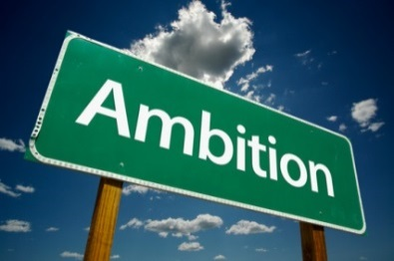 The spectrum of issues covered by the environment, sustainability and climate change is so broad that the wish list could almost be open ended. The following are some of the issues and ideas covered in the limited time available. We hope to add to, explore and tackle these further as a group in the future.

- Find more opportunities to both be active and reduce our carbon footprint.
- Use the positive feeling nature gives to positively affect our communities.
- Build better relationships and opportunities to experiences and knowledge.
- Reinstate a sense of Sabbath and rest, which stands opposed to consumerism and consumption.
- Highlight the health and economic benefits of sustainable life styles.
- Encourage and empower people to take responsibility for living more sustainably.
- Raise awareness of air pollution.
- Become ‘environmental champions’ in our communities, taking the lead on necessary issues.
- Share limited resources.
- Share resources and ideas so we don’t keep ‘reinventing the wheel’.
- Promote awareness of the Anthropocene and Sustainable Development Goals http://www.anthropocene.info/global-goals.php.
- Look at carbon footprints; compare them and account for them.
- We should try to adopt a circular, rather than the current linear, economy of resources https://www.ellenmacarthurfoundation.org/.
- Find out more about local climate strategies https://www.wirral.gov.uk/about-council/climate-change-and-sustainability/cool-climate-change-strategy http://liverpool.gov.uk/council/strategies-plans-and-policies/environment-and-planning/climate-change-strategic-framework/ .
- We need to make sense of the economic complications of failing to properly treat waste as a resource.
- There should be economic incentives for taking extra sustainability steps.
- Learn more on how to insulate windows and general heating ideas for old listed buildings.
- Look at how community centres and other community buildings have been able to increase their efficiency and produce energy.
- Incentivize the extra steps it sometimes takes to be more environmentally sustainable.
- Be more aware of local food & energy sources, for example, Fair Trade http://www.fairtrade.org.uk/.
- Being smarter with our buying of food and how we get rid of it. For instance, consider donating or composting.
- Address both the symptoms & the causes of our carbon footprint’s effect on the world.
- Make it easier to know what is recycle-able and what is not through the production or dissemination of guided leaflets.
- Treat our ‘waste’ as a ‘resource’, not a problem.
- Find a way to make information sharing regarding waste & recycling simpler. This should include as many different groups as possible, as we are ALL stakeholders.
- Faith communities should encourage groups and individuals to go and practice good environmental practices at home, for example energy savings and reducing waste. We should challenge ourselves and others to do something each week or month.
- Perhaps we could produce eco tips in circulars like services sheets and hold an environment day or week.
- Focus on creation care during everyday worship.
- There is a link between energy and health. Looking after sick people is energy intensive. If people are healthier, then this will have a knock on effect.
- Use video and social media to engage people. People have a short attention span and soon move on unless a message grabs their attention.
- A question was raised as to where the health professionals are when there are conferences and events like this on climate change and energy? We should invite them to future events.
- Educate people on how to get energy use from the ‘red’ zone to ‘green’ zone on their smart meter. They don’t necessarily know just how much energy they use if they fill a whole kettle to make one cup of tea instead of just using the amount they need for example.
- Perhaps when we cook food together we could share information about energy use and prices. People don’t know basics like put a lid on a pan.
- Perhaps there could be wider, joint ventures?
- Perhaps an energy version of the ‘eatwell’ plate could be found or devised for energy use https://www.bhf.org.uk/heart-matters/healthy-eating-toolkit/eatwell-plate?
- It’s believed that there are volunteers out there who may lack awareness of where they could be of help. We should try to engage them.
- Support the SDG 2030 hub in achieving sustainable development goals https://coethica.com/2017/07/19/liverpools-latest-signing-new-2030-hub-to-score-sustainable-development-goals/.
- Encourage and promote joined up thinking.
- It was hoped that Faiths4Change will be able to put information from the event on the website http://www.faiths4change.org.uk/ with hyperlinks included.
- As a group, we have something to offer and add – let’s keep the dialogue going (this is being done via email with plans to set up a closed facebook group).
- Consider opportunities to develop our knowledge, perhaps through further events or surgery style sessions in local faith communities

Cool – the climate change strategy for Wirral, identifies a clear role for faith communities in climate change-related action. It recognizes this role, partly because of the buildings associated with their activities, but also because of the in common beliefs and values around caring for the earth and environmental stewardship that all faith communities share. These in common beliefs are embedded in the theology, and ultimately guide how believers live their lives including relationships with the earth and other inhabitants. Faith communities reach in to the wider communities in which they are based – engaging people in prayer and worship and non -worship services including disseminating information and leading on community action.

Reflections and conclusions

People of faith participating in this event identified some of the key strengths that they all share, whatever faith community they belong to, and some challenges to work through to grow their local influence on climate change action:

- We should not forget the power of prayer.
- Faith communities are good at bringing people together.
- Faith communities have an international role and can tell global stories.
- Great things have been achieved by and through faith communities. For example the Fair Trade campaign.
- There is a faith community in every community. Even the most deprived.
- These issues are often hard to prioritize in deprived areas where the focus is day to day survival.
- People in city centres can have a sense of disconnect from the environment and nature.
- People in affluent communities also often don’t have time to address these issues due to pressures on their time and a sense of disconnection.
- It is important to speak truth to power, including politicians and decision makers, as well as to focus on communities.

Feedback following the event was very positive with people most appreciating the opportunity to network and exchange knowledge and ideas, often for the first time around faith and climate change. All who filled in feedback sheets agreed that the event met, or exceeded, expectations. Comments included ‘very interesting’, ‘thought provoking’, ‘inspired’ and ‘very engaging and inclusive’.

Some suggestions were made on ways to improve future events. These included circulating information and topics for discussion groups prior to the event, perhaps taking a more focused approach to future discussions and more of a plenary session at the end to sum up. It was also suggested that microphones could be used to improve audibility during the event and that more advertising might benefit future events. Ideas for moving forward included a closed facebook group, local surgery style events, an energy advice referral process and visits to each other’s communities. In the short term, Faiths4Change, supported by the other partners have been emailing a news feed on a regular basis. The Facebook group is being set up and exploration on additional steps is being undertaken in early 2018.

Through this event we have directly helped advance the Wirral climate strategy and support wider work across the City Region. In meeting together to share ideas, experiences, good practice and information we have worked with members of faith communities to enhance the work of faith communities as important hubs for wider action and influence on climate change.

The team at Faiths4Change and all partners involved in delivering the event would like to thank you for taking time to come along to the event and getting involved. We found it an incredibly positive experience which has opened the door to close collaborative working across the river Mersey and within the City Region. We hope there will be many more occasions for us to get together to share with, and encourage each other. We will work on bringing together resources and creating a network through which this group can communicate. Meanwhile, we hope that this report and the links provided will act as a reminder of the day and be of help in providing you with the information and inspiration for further action towards a more sustainable future. As a first step, we hope that it provides a basis for you to report back about the event in your community and so prompt further conversation and action.

The following is a list of links to faith based environmental networks and information sites which were included in the delegates pack at the event.

Appendix: Faith based environmental initiatives

- https://earthcharter.org/virtual-library2/images/uploads/ECGuideRelClimate2ndEdition.pdf
A piece of work done in USA on all religions and their beliefs towards climate change.

- http://christianaid.org.uk/campaigns/climate-change-campaign
Christian Aid Climate Change Campaign centred around ‘the big shift’ whereby they are aiming to move people to renewable energy sources. Lots of Campaign archives but no conferences

- http://www.ifees.org.uk
Faith initiative based on Islamic beliefs, in Birmingham.
Have online campaigns, online presentation of how you can contribute etc…

- http://brightnow.org.uk/
Church of England run organisation @Bright Now’ is a campaign run by Operation Noah, an ecumenical Christian charity providing leadership, focus and inspiration in response to the growing threat of catastrophic climate change. We are part of a growing global movement calling for disinvestment from fossil fuels (also known as divestment), but have chosen to focus specifically on churches in the UK

- http://operationnoah.org/who-we-are
Operation Noah was set up in 2004 to provide a Christian response to the climate crisis. We work with all Christian denominations and support interfaith work on climate change. Our work is informed by the latest science on climate change, its causes, impacts and solutions. The sense of urgency we feel because of the science is balanced by our faith in God and our hope in his future for our world. We are faith-motivated, science-informed and hope-inspired.

- http://www.biggreenjewish.com/
Joined the Noah operation as a strand from Judaism, member of Climate Change Coalition. Now part of the Jewish Vegetarian Society.
Linked to sustainable food and growing your own crops. UK based charity.

- https://www.muslimclimateaction.org.uk/who-we-are/
UK based group –
- Share best practice on climate change campaigning and programmes amongst member organisation to build our capacity and expertise
- Showcase work being undertaken by UK Muslim organisations to address climate change
- Highlight Islamic perspectives on the environment and climate change issues among Muslim communities, the media and the wider society

- Represent Muslim voices in the UK on climate change by joining together for campaign activities and moment

Appendix: Faith based environmental initiatives

https://www.facebook.com/TheEcoMuslim/ Wants to change behaviour to preserve the Earth’s ecosystems, natural resources, beauty and environment. They are committed to empowering young people to lead the way in making their families, communities and countries eco-responsible.

- http://earthcharter.org/news-post/faith-and-climate-change-conference-held-in-london/
The conference brought to light that many participants of different faiths seemed to agree on some very basic values, such as respect, reverence, repentance, humility, and the wish to leave a healthy world for their children and grand-children. As Shareen Iqbal from Malaysia summed it up beautifully: “The answer is love.”

- https://www.churchofengland.org/about-us/our-buildings/shrinking-the-footprint.aspx
Shrinking the footprint, this initiative is the Church of England’s national environmental campaign, it includes things like energy audit online and simple steps to take action against climate change.
Grants available for church repairs – https://www.churchofengland.org/about-us/our-buildings/our-grants.aspx www.ChurchCare.co.uk
About their work with other faiths – https://www.churchofengland.org/about-us/interfaith.aspx

- http://www.chester.anglican.org/news/2012-environmental-policy-statement.php
Environmental Statement by Diocese of Chester shows the Anglican Church view of climate change and sustainability.

- https://www.interfaith.org.uk/about

- http://climatesafety.info/what-we-all-can-do/what-religious-leaders-and-communities-can-do/
An Australian led website. Uses very simple examples of what a community, individual or faith can do to combat climate change and what a difference you can make. For example, it has simple diagrams of what can be done and what impacts it will help reduce.

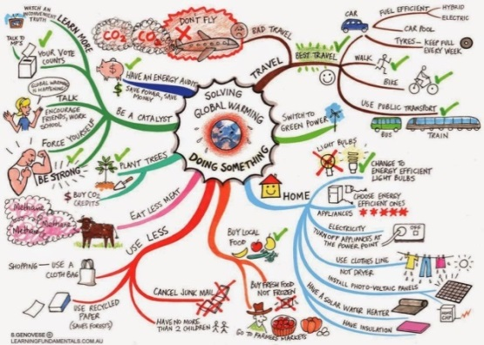
It has similar ideas to energy efficiency and good housekeeping ideas as in the strategy, which it has then shortlisted to a top ten, making it very simple to understand. http://climatesafety.info/what-we-all-can-do/#shortlist

Appendix: Faith based environmental initiatives

- http://www.greenchristian.org.uk/green-action/climate-action/
Similar to most of the others, although more about action as a group and making voices heard. Less on suggestions for individuals and housekeeping. Has links to other initiatives such as: https://www.the climatecoalition.org/about-us/
Green Christian linked to http://brightnow.org.uk/ as was Operation Noah, refer to (4).

- http://www.tearfund.org/en/about you/action/ is another similar link which focuses on food waste and energy waste; it also links to the big switch. https://bigchurchswitch.org.uk/ this also ties to Christian Aid and their Big Shift.

- http://christian-ecology.org.uk/weblinks.htm
Links to many Christian organisations looking at some part of climate change action.

- http://arocha.org.uk
and http://www.ecocongregation.org/ is another spin off / link to Arocha
https://ecochurch.arocha.org.uk/eco-diocese/ idea of a whole eco diocese, brings into the question of who do you invite. More so surrounding just Christianity, not all faiths.

- http://www.jri.org.uk/nature-in-the-balance/ Runs research and annual event looking at the impacts of climate change and how we can help to combat it. Uses ideas such as ecosystem services and starts globally then narrows down to individual contributions. They are linked to A Rocha and Tearfund (see 15 and 17 above).

- http://www.livingwitness.org.uk/ “About 80 Quaker meetings are now involved with Living Witness, connecting our spiritual life as worshipping communities with our witness for a sustainable world. Momentum is growing as Friends Learn and work together, with regular groups and action to green their lives and Meeting, practical projects in their local communities, and engagement with local and national government”

- http://cafod.org.uk/Campaign/How-to-campaign/Livesimply-award Looks at creating sustainability, and working with communities from the Roman Catholic Church.
“Some livesimply award communities have encouraged people to walk or cycle to church or school, install solar panels, start recycling schemes, join a climate change campaign, support Fairtrade stalls or donate to a local Food Bank. The award celebrates what you have already done and inspires you to do more. It helps your community to live, not just more simply, but also more fully.”

- https://www.sageoxford.org.uk/who-we-are/ Focuses on sustainability and linking it to prayer meetings. It is based in Oxford and uses similar terms like SIMPLE LIVING.

Appendix: Faith based environmental initiatives

- http://www.churchestogethercumbria.co.uk/get-involved/83-lifestyle-churches Uses similar phrases; Living Lightly to promote sustainable living. Interesting idea about linking a church suffering from the effects of climate change around the world! Similar idea seen in Eco congregation and global neighbours. Links to similar organisations such as CAFOD, Eco congregations and Christian Ecology.

- http://www.lpwscheme.org.uk/4step_process.html Grant application area for listed churches to fund energy efficiency projects

- http://buildingconservation.com/articles/parish-church-funding/parish-church-funding.htm Similar to above.

- http://www.dcga.org.uk/ Uses similar ideas to other local green action and again links to Arocha and Eco Church

- http://ecosikh.org/ Similar to above.

- http://www.greenfaith.org/about/mission-and-areas-of-focus

- http://www.nrpe.org/ National religious partnership for the environment

- https://laudatosi.com/watch Pope Francis' encyclical on the environment and human ecology

