Writing a letter to your local MP

Who is your local MP?
To find out who your local MP is, you can research online.
Search www.parliment.uk
Scroll down and click on MP and Lords
Type your postcode or your town into the Find your MP search box.
And you will see the name of your local MP.

What would writing a letter do?
By writing a letter to your local MP you are raising an issue to them which they may have never thought about. This can them drive them to find a solution to the problem.

What can an MP do to raise an issue?
Your MP can raise your concern in the House of Commons to be discussed with MP’s from all over the country to see if there is any way that they can find a solution to your concerns.

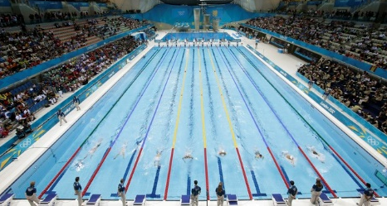
Some key facts that you could include in your letter?
- It takes around 2700 litres of water to produce a single t-shirt (this is the amount of water to fill an Olympic sized swimming pool).
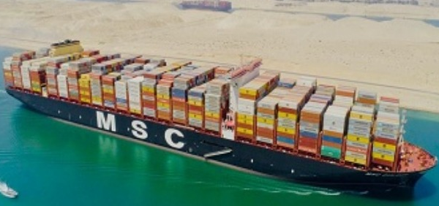
- It is estimated that 1 container ship (this transports our clothes), and is the length of around 6 football pitches, can produce around the same amount of pollution as 50 million cars.

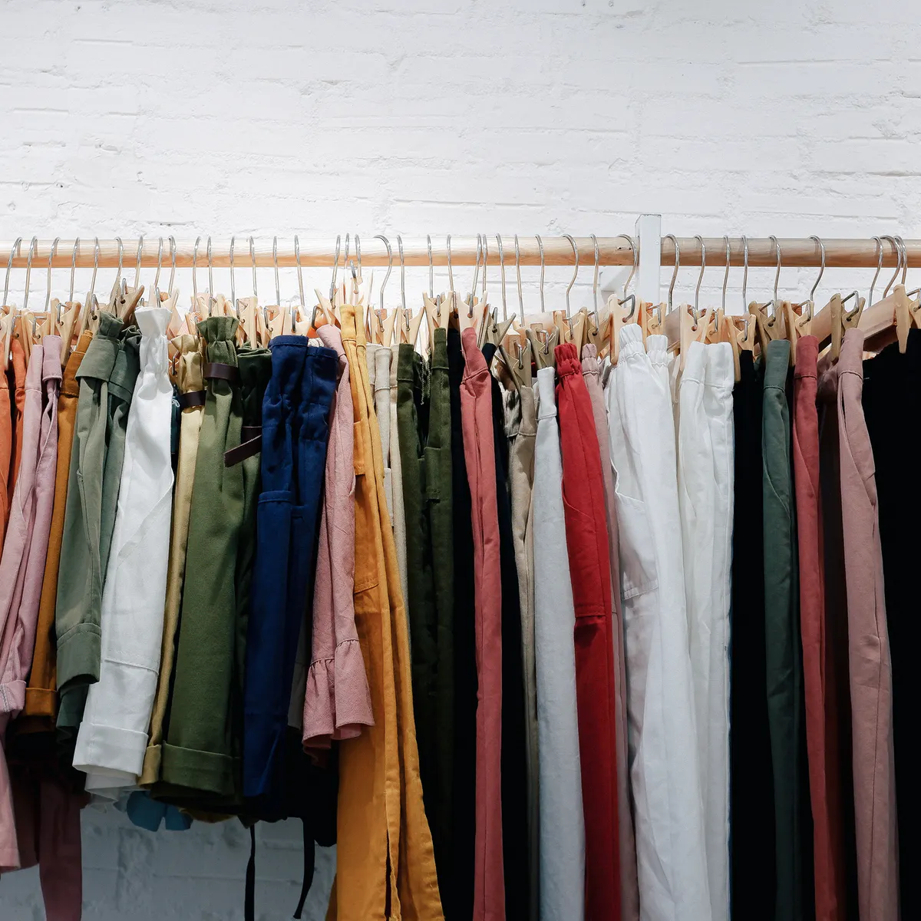
- The average UK household owns around £4000 worth of clothes, but around 30% of these clothes do not get worn.
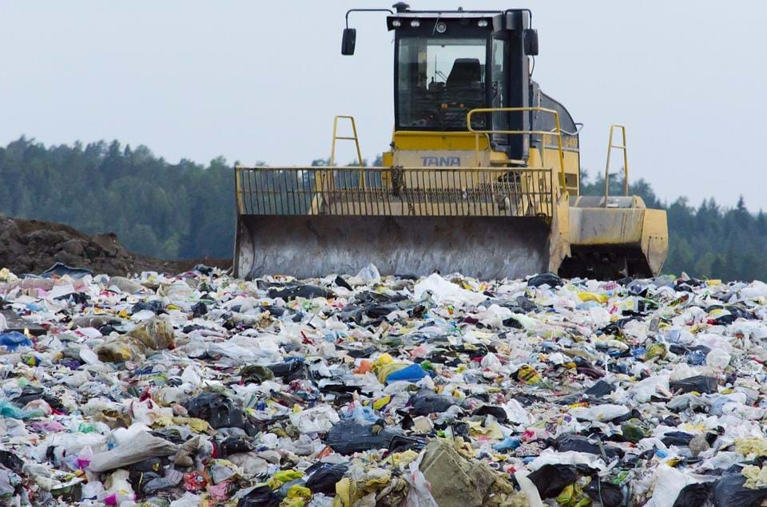
- In the UK alone, it is estimated that £140 million worth of clothes are sent to landfill or incinerated (burned) each year.

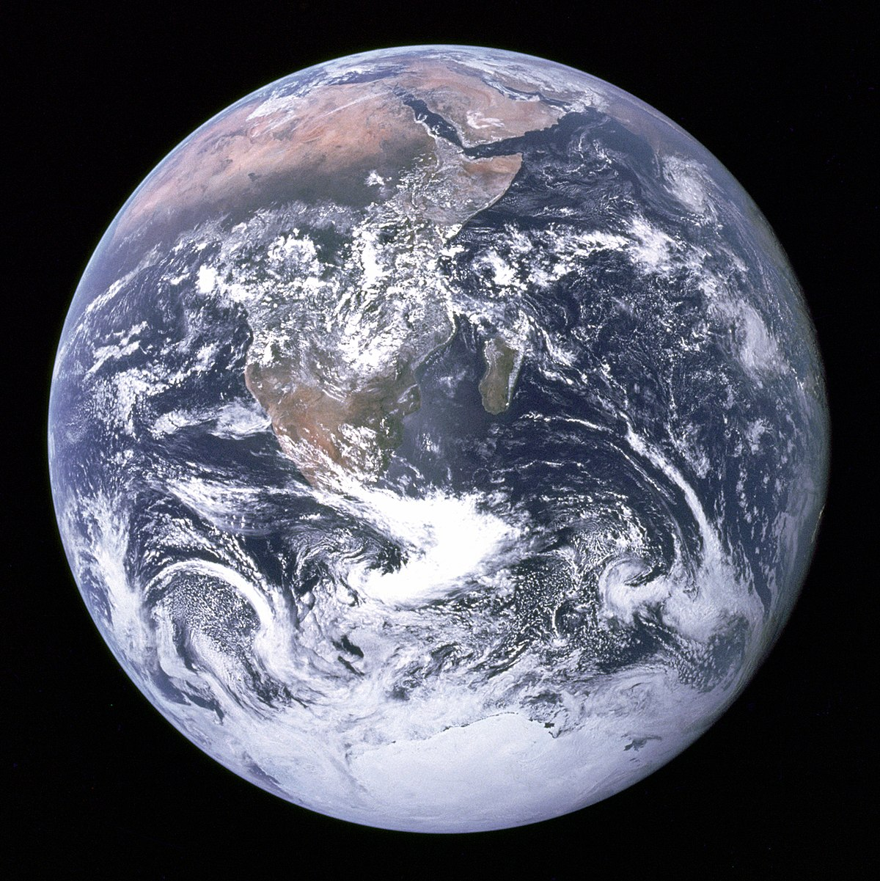
- If we covered the earths surface with just new fabric that has been produced, we would cover around 78% of the surface,

In what ways can we help?
- Better recycling of fabrics and old clothes.
- Encourage up-cycling more.
- Donate to charity.
- Buy less new clothes.
- Speak to large companies in the fast fashion industries.
- Educate communities to waste less.

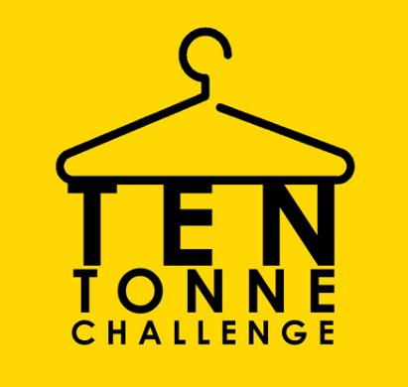
My Letter to the MP
………………………………………………………………………………………………………………………………………………………………………………………………………………………………………………………………………………………………………………..
Date:…………………………………………

Dear………………………………………………
Congratulations on your successful election. I am a pupil at a local primary school in your constituency. I would like to introduce myself.
My name is………………………………………………………………………………………………… and I am…………………………… years old.
I have been learning about how the fashion and textiles industries affect the climate and earth that we live in at school.
I would like to know what you are planning to do about…
……………………………………………………………………………………………………………………………………………………………………………………………………………………………………………………………………………………………………………………………………………………………………………………………………………………………………………………………………………………………………………………………………………………………………………………………………………………………………………………………………………………………………………………………………………………………………………………………………………………………………………………………………………………………………………………………………………………………………………………………………………………………………………………………………………………………………………………………………………………………………………………………………………………
This issue is important because… (give some key facts)
……………………………………………………………………………………………………………………………………………………………………………………………………………………………………………………………………………………………………………………………………………………………………………………………………………………………………………………………………………………………………………………………………………………………………………………………………………………………………………………………………………………………………………………………………………………………………………………………………………………………………………………………………………………………………………………………………………………………………………………………………………………………………………………………………………………………………………………………………………………………………………………………………………………
…………………………………………………………………………………………………………………………………………………
I think that you should…
……………………………………………………………………………………………………………………………………………………………………………………………………………………………………………………………………………………………………………………………………………………………………………………………………………………………………………………………………………………………………………………………………………………………………………………………………………………………………………………………………………………………………………………………………………………………………………………………………………………………………………………………………………………………………………………………………………………………………………………………………………………………………………………………………………………………………………………………………………………………………………………………………………………

Thank you for taking the time to read my letter. I look forward to hearing back from you.
Yours Sincerely,
………………………………………………………

