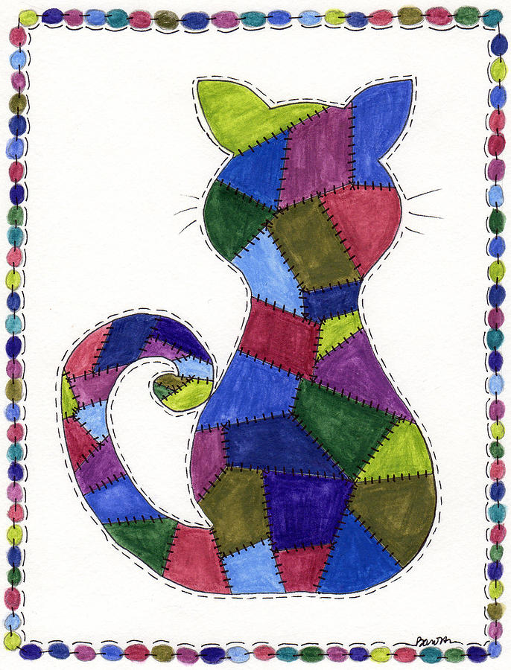
Patchwork Cat

Patchwork Cat is made from this and that
Bit of fabric, buttons, hats
A piece of cotton from dad’s torn shirt
A button that came off mum’s old skirt
A square of wool from a too-small dress
A dazzling blue that’s bound to impress

Every fabric has a story to tell
And this is where we want your thoughts to dwell
Do you know how your clothes were made?
Denim, polyester, cotton or suede
The Earth is affected by the clothes we choose to buy
Write a poem to tell us why…

